Assignment -2

Data Visualization and Pre-processing

|  |  |
| --- | --- |
| Assignment Date | 06 October 2022 |
| Project name | AI or A Noval Method For Handwritten Digit Recognition System |
| Team Id | PNT2022TMID17271 |
| Maximum Marks | 2 Marks |

Question-1:

Download the dataset:

The dataset “Churn_Modelling.csv” was downloaded Successfully

Question-2:

Load the Dataset:

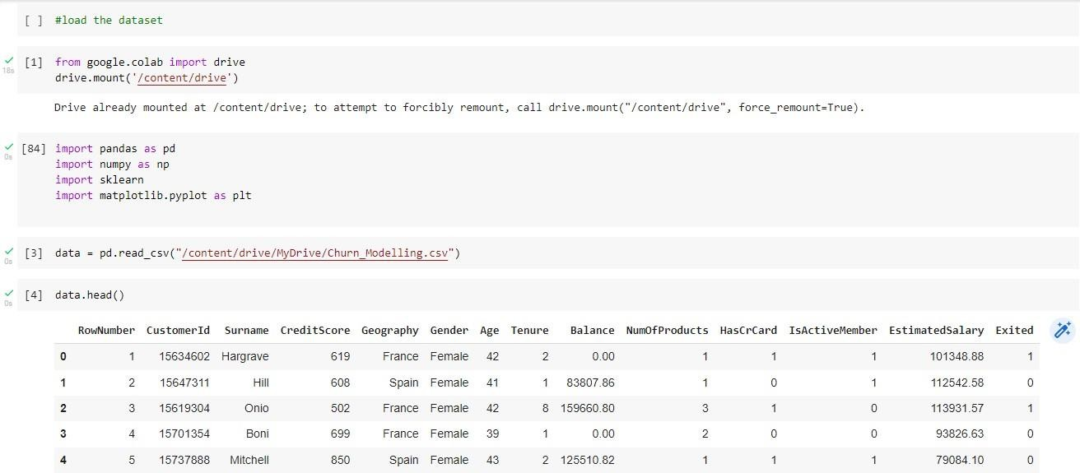

Question-3:

Perform Below Visualization: Univariate Analysis



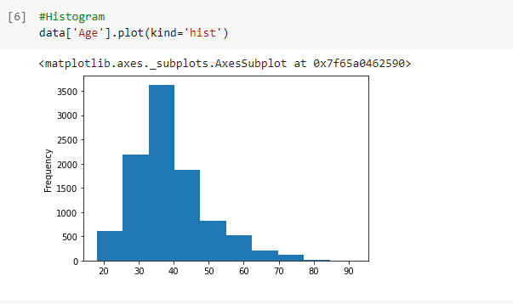 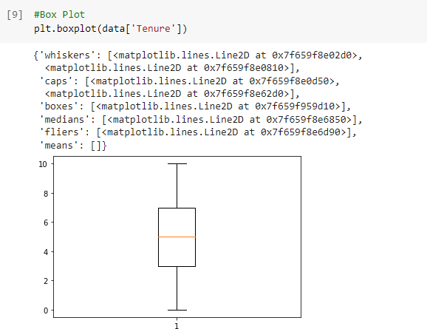

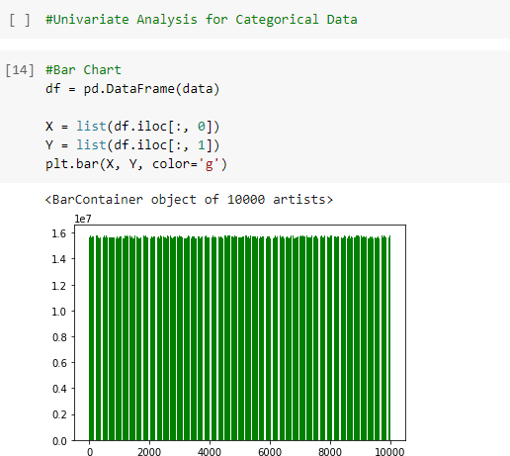

Bivariate Analysis

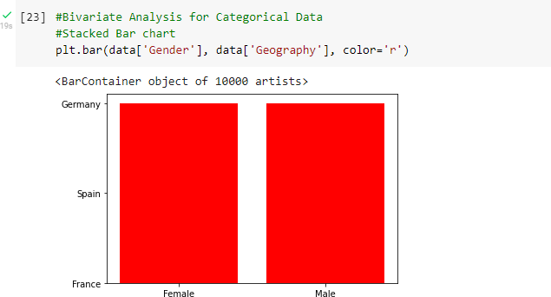

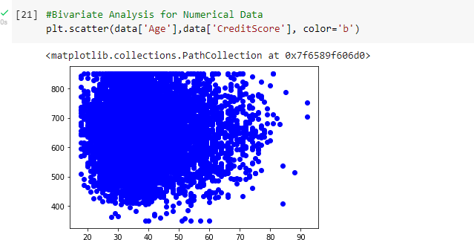

Multivariate Analysis

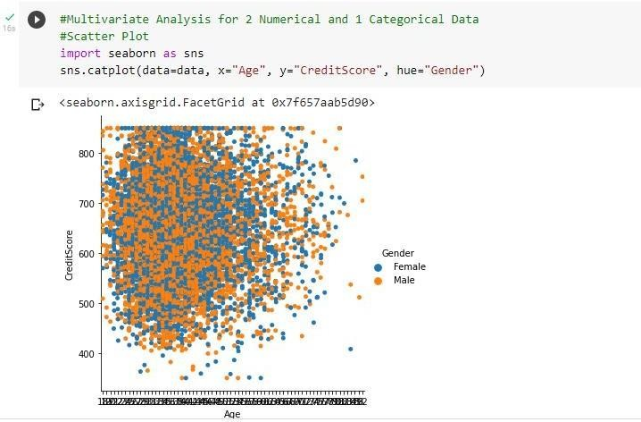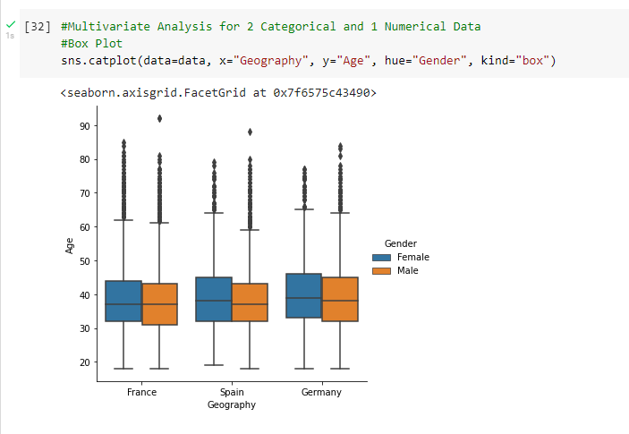

Question-4:

Perform Descriptive Statistics on the dataset:

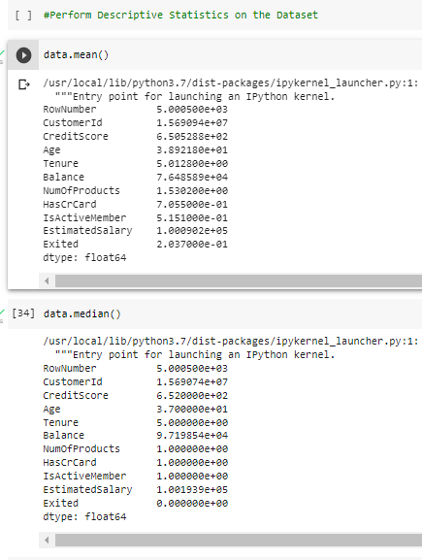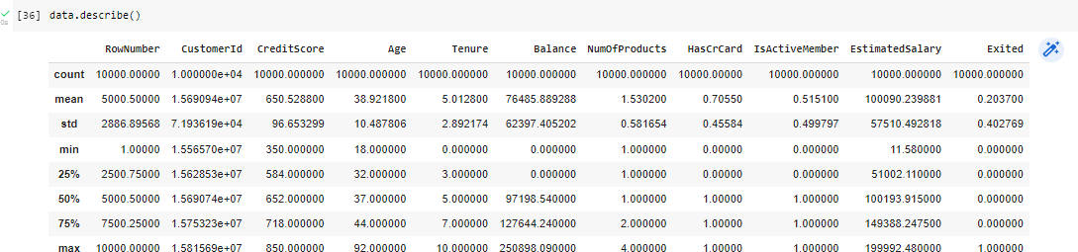



Question-5:

Handle the Missing values:

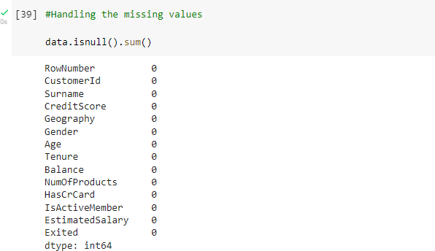

Question-6:

Find the outliers and replace the outliers:

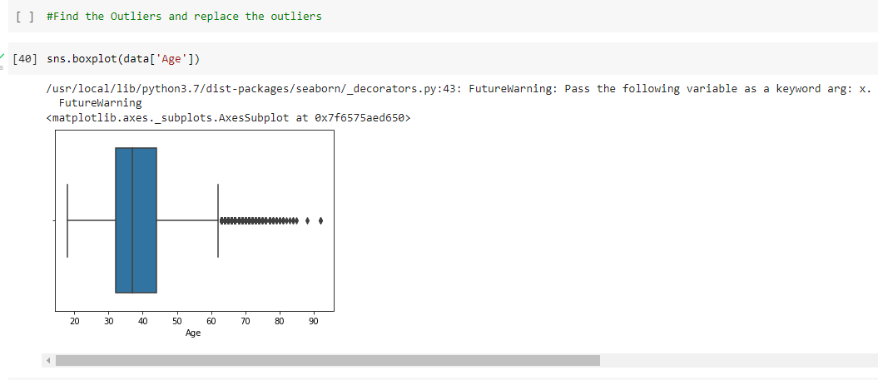

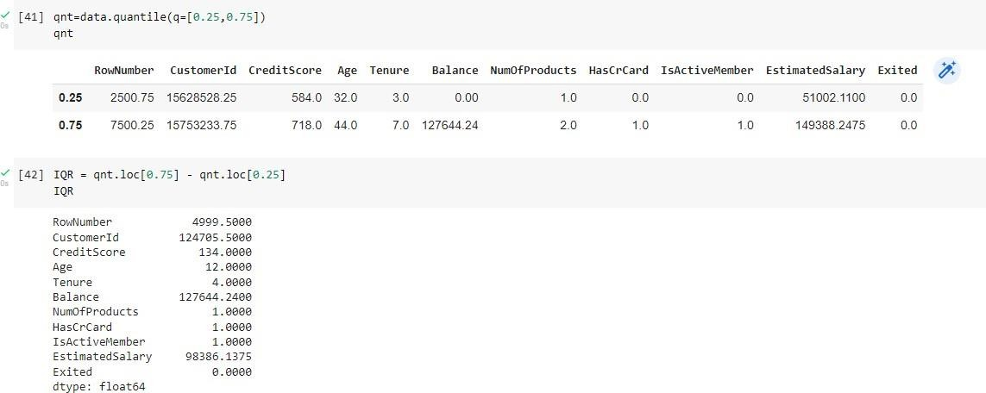

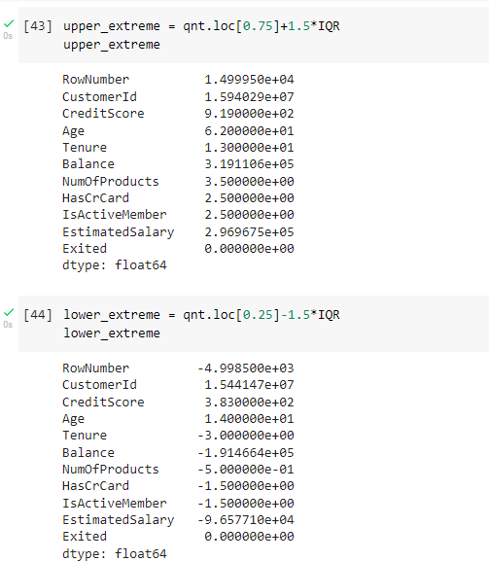

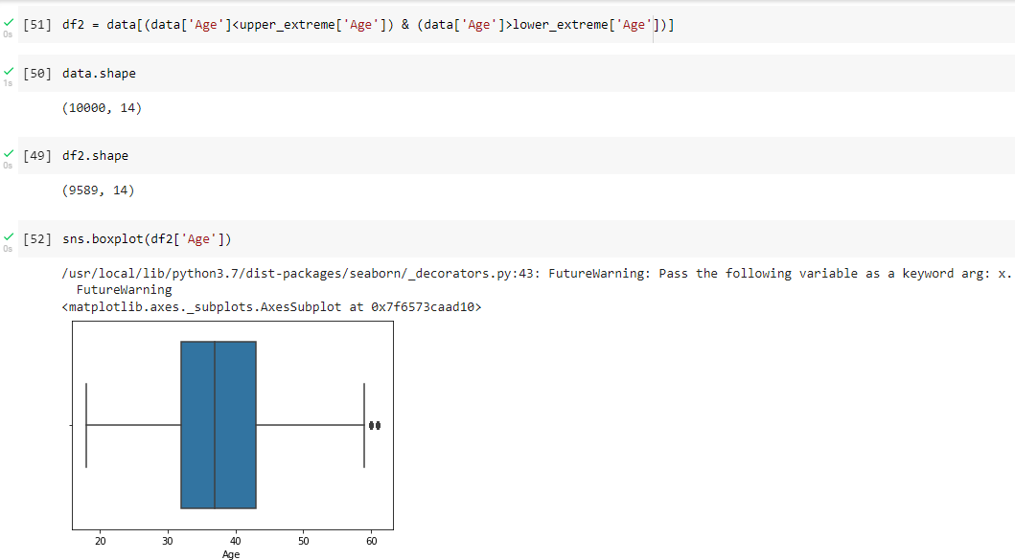

Question-7:

Check for Categorical columns and perform Encoding:

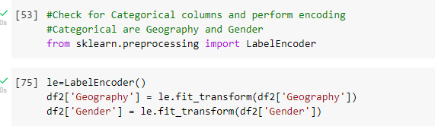

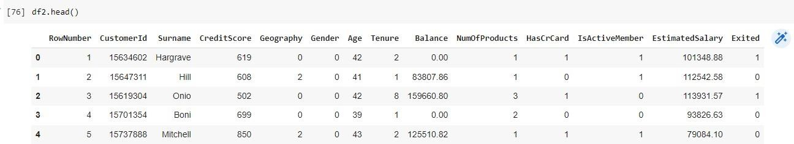

Question-8:

Split the data into dependent and independent variables:

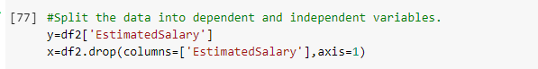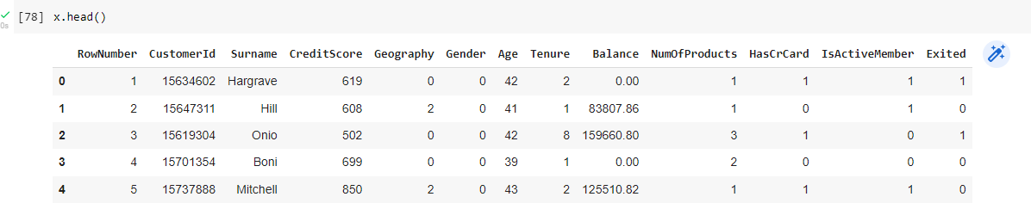

Question-9:

Scale the independent variables:

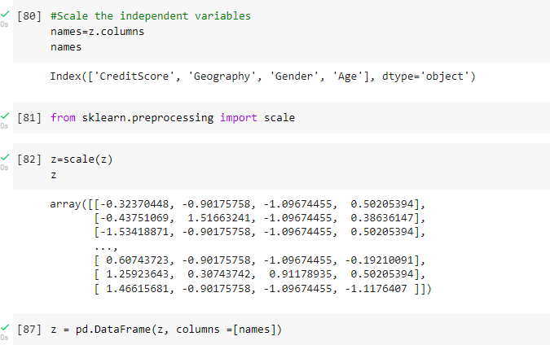

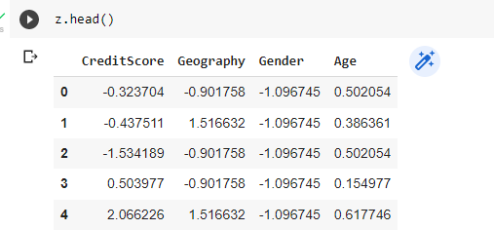

Question-10:

Split the data into training and testing:

